**Background**

The project is for all AutoZone locations to use as their retail Point of Sale System. This will be an upgrade from the current system as it tends to lag and cause unnecessary wait times for the customer in the store trying to go about their day. This system will be customized to be able to add, delete, and revise current products and properties about them like price, name, and quantity in stock.

**Benefits**

The main benefit will be to speed up the time it takes to check out at any AutoZone location. It will also give the cashier full confidence in knowing that whatever item the customer is trying to purchase is available even if it’s not visible in the front of the store. Overall, this will benefit both the lives of the cashier, business owners and customers by providing a seamless checkout experience.

**Key Features**

Key features include:

* Database of current items for sale
* Ability to search for items by name, category, product number, brand name, and model number/name.
* Ability to revise prices for sales and to keep up to date with market prices
* Ability to delete items temporarily if out of stock or permanently if the item has been discontinued or the business owner decides to stop selling certain items
* Ability to add items when new product is delivered to provide a seamless experience to introduce product into the purchasable items list
* Ability to save customer profiles with payment information if they decide to opt in to make their next visit even faster
* Update current stock of items when a sale happens so that the system will always know what is or isn’t in stock
* Ability to view stats that show an average for products sold for a current day, week, or month to show trends for marketing and ordering purposes. This will have the ability to be filtered by product categories and brand names

**Comparison with similar apps**

There are similar apps that can do some of the same things however it is certainly better to have a custom-made app that can do everything you need it to do for your business. In this case the above features are what we need to make sure the front-end of the business runs smoothly and will also help the ordering side of the business to see what should be ordered based on sales for that week or month and help the marketing team figure out what is and is not selling.

**Design Ideas**

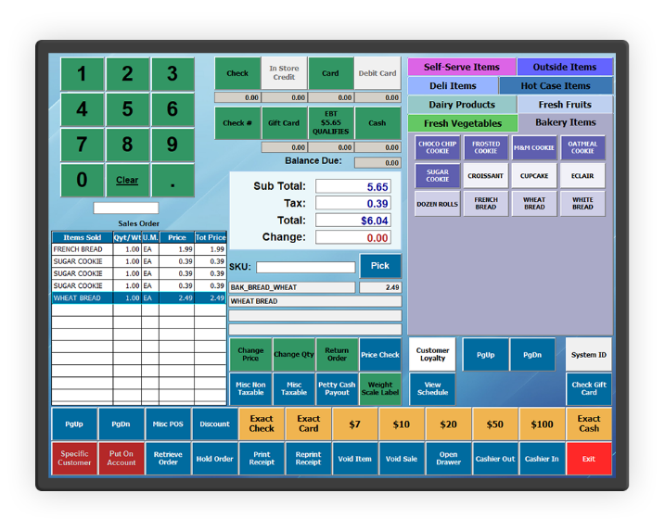

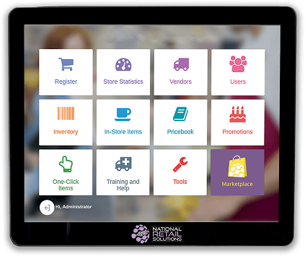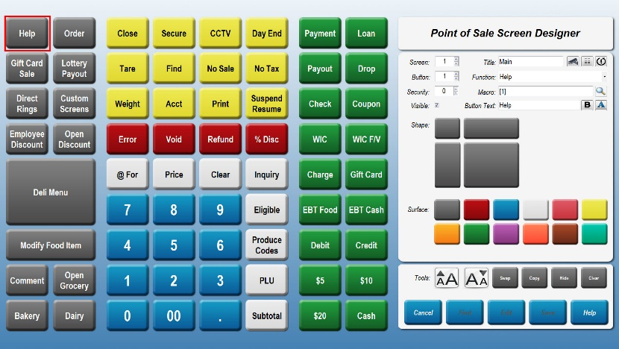

**Approval Signatures**

|  |
| --- |
| **JOSHUA B MANDEL** |
| Joshua Mandel, Student | |  | [Name], Instructor |